

**Weather v. Climate**

**What is the primary difference?**

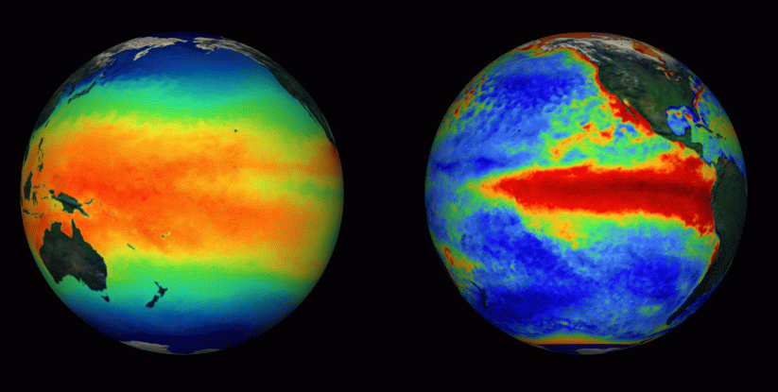

The difference between weather and climate is a measure of time. Weather is what conditions of the atmosphere are over a short period of time, and climate is how the atmosphere "behaves" over relatively long periods of time.

When we talk about climate change, we talk about changes in long-term averages of daily weather. In summary, climate is made up of prolonged weather patterns.

**Defining Weather**

Weather is essentially atmospheric patterns. This does not necessarily reflect anthropological effects like emissions or pollutions. Weather can considered the natural way for our planet to express temperature, humidity, precipitation, cloudiness, brightness, visibility, wind, and atmospheric pressure, as in high and low pressure.

**Defining Climate**

Unlike weather, climate is the description of the long-term pattern of weather in a particular area. According to many scientists, climate is defined as the accumulation to weather over a period of time equivalent to 30 years. This observation is generally done using average weather patterns.   
  
When discussion climate we generally discuss averages of precipitation, temperature, humidity, sunshine, wind velocity, phenomena such as fog, frost, and hail storms, and other measures of the weather that occur over a long period in a particular place.   
  
For example, after looking at rain gauge data, lake and reservoir levels, and satellite data, scientists can tell if during a summer, an area was drier than average. If it continues to be drier than normal over the course of many summers, than it would likely indicate a change in the climate.   
  
**Why Study Climate?**

The reason studying climate and a changing climate is important, is that will affect people around the world. Rising global temperatures are expected to raise sea levels, and change precipitation and other local climate conditions. Changing regional climate could alter forests, crop yields, and water supplies. It could also affect human health, animals, and many types of ecosystems. Deserts may expand into existing rangelands, and features of some of our National Parks and National Forests may be permanently altered.